**Browser Working :**

Browser part :

Data,

UI,  
Browser Engine,

Render Engine,

JS Engine

Network,

Timers

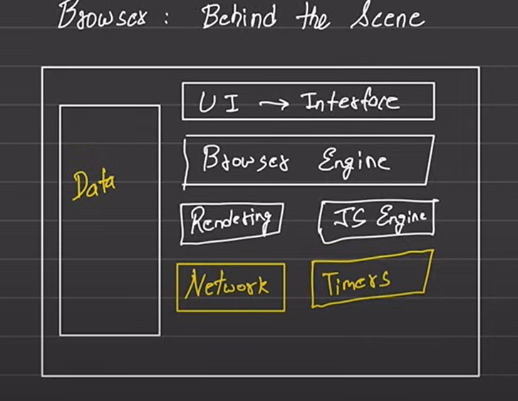

**How Page Renders in a Browser:**

**DOM (Document Object Model):**

1. **HTML file** is loaded as **raw bytes**.

2. **Characterizing**: Bytes are converted into characters (based on encoding, like UTF-8).

3. **Tokenizing**: Characters are split into tokens (like tags, attributes, etc.).

4. **Parsing**: Tokens are parsed into nodes.

5. **DOM** **tree** is constructed from these nodes.

**CSSOM (CSS Object Model):**

1. **CSS** **file** is loaded as raw bytes.

2. **Characterizing**: Bytes are converted into characters.

3. **Tokenizing**: Characters are split into tokens (like selectors, properties).

4. **Parsing**: Tokens are parsed into nodes.

5. **CSSOM** **tree** is built.

**Relationship:**

- **DOM** **tree** and **CSSOM** **tree** are created separately.

- Both are combined to form the **Render** **Tree**.

- The Render Tree is passed to the **Rendering** **Engine** for visual layout and painting.

**JavaScript Interaction:**

- **DOM** **parsing** **stops** when a `<**script**>` tag is encountered, and JavaScript is executed.

- JavaScript can modify the DOM and CSSOM.

- **CSSOM** **must** **be** **complete** before rendering, as styles are needed for layout, but JavaScript execution may block the building of the CSSOM.